|  |  |
| --- | --- |
| **CS M152A Project 4** | **Due Date : 5/24 11:59pm** |

**Finite State Machine Design : Vending Machine**

*In this lab, you will design and implement a finite state machine (FSM) for a vending machine.*

**Introduction**

For this lab, you will:

1. Design a finite state machine that matches the specified behavior
2. Use the Xilinx ISE software to design and test the working of your state machine

This lab will be based on simulation only; no FPGA use will be involved. you are going to implement your design in Verilog HDL. At the end of the lab, you are expected to present a design project with source code and test bench.

**Overview and Example**

Finite State Machines (FSMs) are a powerful tool that can be used to model many real world systems, and are particularly useful for the behavioral modelling of sequential circuits. An FSM has a finite number of ‘states’ and can be in any one of these states at a given time. The machine transitions from one state to another based on the inputs it receives and the state that it is currently in. The machine must begin operation in an initial state. Given below is a simple example of an FSM for a turnstile, and the verilog code to implement it. This FSM is a Moore machine, because the output (*is_locked*) depends only on the present state. A Mealy machine is an FSM whose outputs depend both the present state and input.

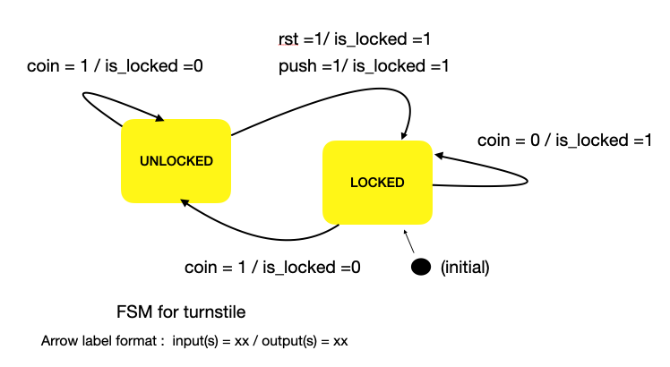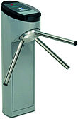

Fig 1 : FSM for a Turnstile (allows a user to push through when a coin is inserted)

module turnstile(rst,clk,coin,push,is_locked);

input rst,clk,coin,push;

output reg is_locked;

parameter LOCKED = 1'b0;

parameter UNLOCKED = 1'b1;

reg current_state;

reg next_state;

// always block to update state : sequential - triggered by clock

always@(posedge clk)

begin

if(rst)

current_state <= LOCKED;

else

current_state <= next_state;

end

// always block to decide next_state : combinational- triggered by state/input

always @(*)

case(current_state)

LOCKED : begin

if(coin)

next_state = UNLOCKED;

else

next_state = LOCKED;

end

UNLOCKED:

begin

if(coin)

next_state = UNLOCKED;

else if(push)

next_state = LOCKED;

else

next_state = UNLOCKED; //stay unlocked until push

end

endcase

//always block to decide outputs : triggered by state/inputs; can be comb/seq.

always @(*)

case(current_state)

LOCKED : begin

is_locked = 1'b1;

end

UNLOCKED:

begin

is_locked = 1'b0;

end

endcase

endmodule

**System Specifications:**

This section describes that behavior of the FSM that you are expected to design.

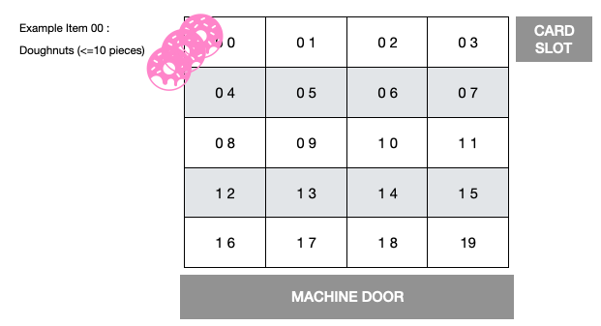

Fig 2: Vending Machine

Design a vending machine with the following characteristics:

1. The vending machine has 20 different snacks for sale. Each snack has a two digit code (00 to 19).
2. Each snack is stored in a separate slot like the vending machines on campus (see Fig. 2). There can be upto 10 units of the snack stored in 1 slot. A counter for every slot keeps track of the number of units of the snack remaining in that slot.
3. A buyer can purchase only 1 item at a time.
4. The machine only accepts payment by card.

**Actions**:

1. **Reset** : When reset = 1, all item counters and outputs are set to 0. The machine goes to the idle state when reset becomes 0.
2. **Idle** : This is a state where the machine waits for a new transaction to begin. In this state all outputs are set to 0, and the machine waits in this state until CARD_IN goes high to signal the beginning of a new transaction. The idle state is the initial state of this FSM.
3. **Re-load:** All snack counters are set to 10, i.e. the machine is fully re-loaded. A re-load can only be done when the machine is idle. A new transaction cannot begin when the machine is re-loading.
4. **Transact:** When card is inserted (CARD_IN = 1) - wait for item selection (see action : get code)
   1. If selection is valid (i.e. the code is a number between 00 and 19 and there are a non-zero number of items corresponding to that code left in the machine) , display the $ amount of the selection on COST<2:0> as per Table 1, and wait for the VALID_TRAN signal (simplification of valid/invalid transaction signal from bank).
      1. If VALID_TRAN = 1 : VEND selected item (see action: vend)
      2. If the VALID_TRAN signal does not go high within 5 clock cycles, the transaction failed. Set the ‘FAILED_TRAN’ bit to high, and go to the idle state.
   2. If the selection is invalid, set the ‘INVALID_SEL’ bit to high and go to the idle state.
5. **Vend**:
   1. decrement counter of corresponding item by one (i.e., the item is dispensed)
   2. set VEND to 1
   3. Wait for door-open signal to go HIGH (open) and then (LOW) (i.e. the door opened, the item was collected and door was closed) to begin a new transaction (idle). If the door does not open for 5 clock cycles, go to the idle state.
6. **Get Code:**

1. The same bus (ITEM_CODE<3:0>) is used to enter the 2 digit item code sequentially, the way you would press numbers on a keypad. The press is modeled by the input ‘key_press’. Thus, the item_code is read only when key_press = 1.

2. Wait upto 5 clock cycles for each digit. If no digit is entered, or if a digit is entered and there is no second digit for 5 clock cycles, go to the idle state.

Example: For item ‘16’ entered over 3 clock cycles:

clk cycle 1: ITEM_CODE = 0001 KEY_PRESS = 1 // read.

clk cycle 2: ITEM_CODE = 0001 KEY_PRESS = 0 // not read. max 4 cycles left

clk cycle 3: ITEM_CODE= 0110 KEY_PRESS = 1 // read.

|  |  |  |  |
| --- | --- | --- | --- |
| ITEM CODE | COST ($) | ITEM CODE | COST ($) |
| 00, 01,02,03 | 1 | 12,13,14,15 | 4 |
| 04,05,06,07 | 2 | 16,17 | 5 |
| 08,09,10,11 | 3 | 18,19 | 6 |

Table 1: ITEM CODE vs COST

**Inputs and Outputs:**

The I/O of the module vending_machine should be exactly as shown in Figure 3.

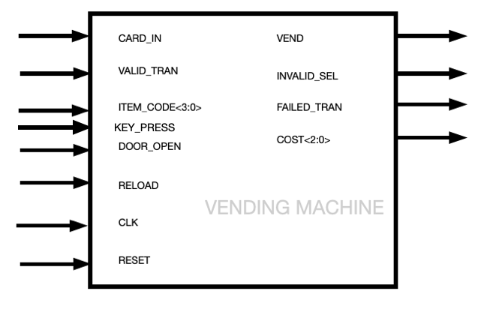

Figure 3 : VENDING MACHINE I/O

INPUTS :

|  |  |
| --- | --- |
| INPUT | SIZE/ BEHAVIOR |
| CLK | 1 bit. System clock ( T= 10 ns) |
| RESET | 1 bit. Set all item counters,outputs to 0 and go to the idle state. |
| RELOAD | 1 bit. Reload the machine (set all item counters to 10) |
| CARD_IN | 1 bit. Stays high as long as the card remains inserted. |
| ITEM_CODE <3:0> | 4-bit signal to input item code. The 2 digit item code is entered one digit at a time. ** |
| KEY_PRESS | 1 bit. ITEM_CODE is valid for read when this signal is high. |
| VALID_TRAN | 1 bit. HIGH = transaction using the card is valid (can go high any time after item selection is determined to be valid)  (card does not need to be inserted when this occurs) |
| DOOR_OPEN | 1 bit. HIGH = The vending machine door is open  (This can occur any time after the ‘VEND’ goes high.) |

OUTPUTS:

|  |  |
| --- | --- |
| OUTPUT | SIZE/BEHAVIOR |
| VEND | 1 bit. Set to HIGH once the transaction is deemed to be valid. Set to LOW once DOOR_OPEN goes high and then low/ or if the door does not open in 5 clock cycles. |
| INVALID_SEL | 1 bit. Set to HIGH if:   1. Only 1 digit of ITEM_CODE is entered and there is no 2nd digit after 5 clock cycles or no digit is entered for clock cycles 2. The 2 digit ITEM_CODE is invalid (Ex. 23) 3. The counter for one of the items is 0. |
| COST<2:0> | 3 bits. Set to 000 by default. Set to the cost of an item once item code is entered, and remains at this value until a new transaction begins. (Ex. $5 = 101) |
| FAILED_TRAN | 1 bit. Set to 1 if VALID_TRAN signal does not go high within 5 clock cycles of determining the ITEM_CODE |

Things to think about/Hints :

1. Draw your FSM diagram before you write any code. What are your states? What inputs cause a state transition? Once your FSM is designed, use the example provided as a template to convert it to verilog.
2. You can use the ‘actions’ as a starting point for your state definitions, but feel free to combine actions into one state or split up an action in multiple states if required. Aim for a clean, logical design with as few states as possible. (As a reference - one possible solution has around 10 states. Your design can have more/fewer.)
3. What happens if any input signal occurs when it is not supposed to? Does your FSM handle this correctly? Your vending machine cannot crash or take an action that violates the design specifications.
4. Additional signals, counters etc. may be defined within the module (invisible outside the module) to help synchronize operations and reduce the number of states.

**Deliverables**

When you finish, the following should be submitted for this lab:

1. **FSM Diagram:** Draw a diagram similar to Figure 1 to represent the working of your FSM. This diagram can be drawn by hand or using software. You can label the arrows (1,2,3, a,b,c etc.) and put the text associated with each arrow in a table if you feel your diagram is getting very crowded. Include this diagram in your report.
2. **Verilog source code** for the “vending_machine” module. The file should be named exactly as “vending_machine.v” and the module and port names should exactly match names defined in Figure 3. It is very important as your code is automatically run. Also note that this code should be completely synthesizable. ***There is no restriction on the naming of the submodules (if any) but make sure to place all the submodules in the vending_machine.v file.
3. **Verilog testbench** you used to evaluate your design. Note that your testbench is graded based on the correctness of the waveforms generated in your report. Please name the file “testbench_UID.v” where UID is your UCLA ID. It is too time consuming to exhaustively test all possible input/state combinations for this design. Make sure you test **at least** one successful transaction and 4 special cases to get 80% of the marks associated with simulation. A testbench which identifies and tests all/most ‘interesting’ cases will get full marks for simulation.
4. **Lab Report**: Please refer to the syllabus for the basic components of your lab report. (Introduction and requirement (~10%) Design description (~15%), Simulation documentation (~10%), Conclusion (~5%)). Note:

* 1. Include the FSM diagram and explain the states and transitions of your FSM. Bullet-points/tables are preferred over lengthy paragraphs.
  2. Explain how you test your design and include simulation waveforms
  3. Schematics can be generated from ISE but please explain how your verilog code results in the RTL generated. Include the ‘Design Summary’ section of the synthesis report and the summary of your implementation (map) report and write 1-2 lines on the conclusions you draw from these reports.
  4. Please name your report “Firstname_Lastname_Project4_UID.pdf” where UID is your UCLA ID.

1. **Video**: Please refer to ‘Syllabus’ for details. Ideal video length is 5-10 minutes. A tentative split up of video time is:
   1. 1-2 min on FSM design
   2. 1-2 min on module design and integration
   3. 2-4 min on testbench design and simulation results

Ideally create just one video file.

Submission Checklist :

* Please submit ONLY the files in this table
* There is no late submission for this project.
* It is recommended that you have your submission ready an hour or two before the deadline so that you do not face problems due to long upload times etc.

|  |  |  |
| --- | --- | --- |
| Type | SUBMIT THESE FILES | Contents |
| Report | Firstname_Lastname_Project4_UID.pdf | - |
| Design | Firstname_Lastname_Project4_codes.zip | vending_machine.v |
| Testbench | testbench_UID.v |
| Video | Firstname_Lastname_Project4_videos.zip | video_UID.()  (extension : some video format - ex. mp4) |

Version Control:

|  |  |
| --- | --- |
| Date | Changes Made |
| 05/09 | reset and ‘idle’ introduced. Deadline extended, and some more hints added. |
| 05/13 | key_press introduced to I/0. Behavior of ‘reload’ clarified. FAQ document created. |
| 05/14 | Changed an inconsistency in the inputs table. **Card does not need to be inserted when INPUT CODE is entered. |